**OUTPUTS**

* **Home Page:**

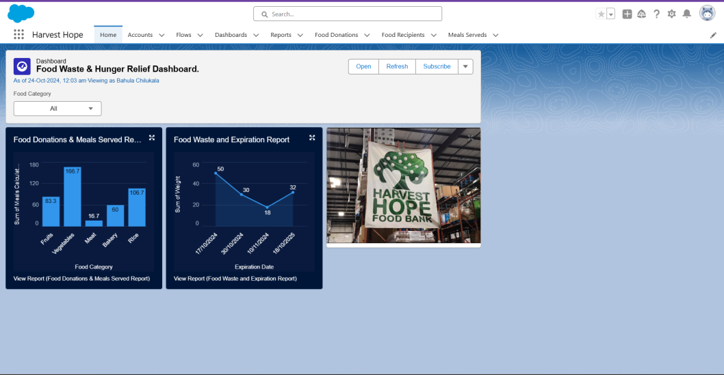

The image shows the "Food Waste & Hunger Relief Dashboard" for the "Harvest Hope" app in Salesforce. It displays two visual reports—one for "Food Donations & Meals Served" and another for "Food Waste and Expiration"—alongside a photo of a "Harvest Hope Food Bank" sign.

* **Food Waste and Expiration Report:**

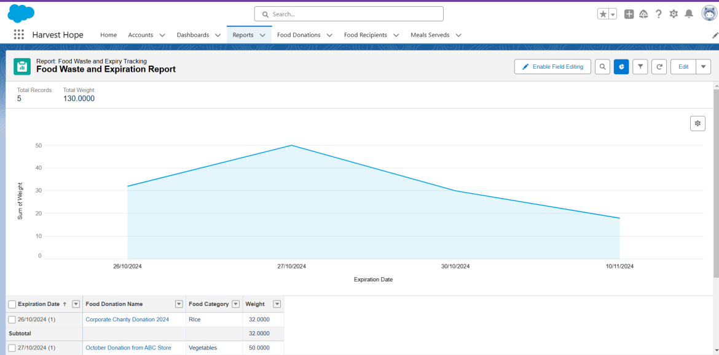

The image shows a Salesforce report titled "Food Waste and Expiration Report" for the Harvest Hope project. It includes a line chart tracking food expiration dates by weight and a table listing food donation names, categories, expiration dates, and weights.

* **Food Donations & Meals Served Report:**

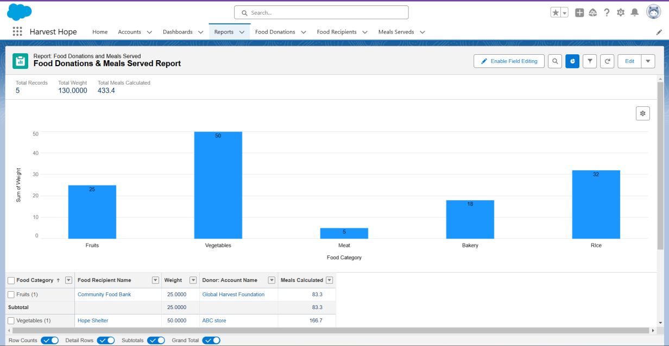

The image displays a Salesforce report titled "Food Donations & Meals Served Report" for the Harvest Hope project, showing a bar chart of food categories by weight and a table detailing recipients, weights, donor accounts, and calculated meals served.

* **Donor Engagement Page:**

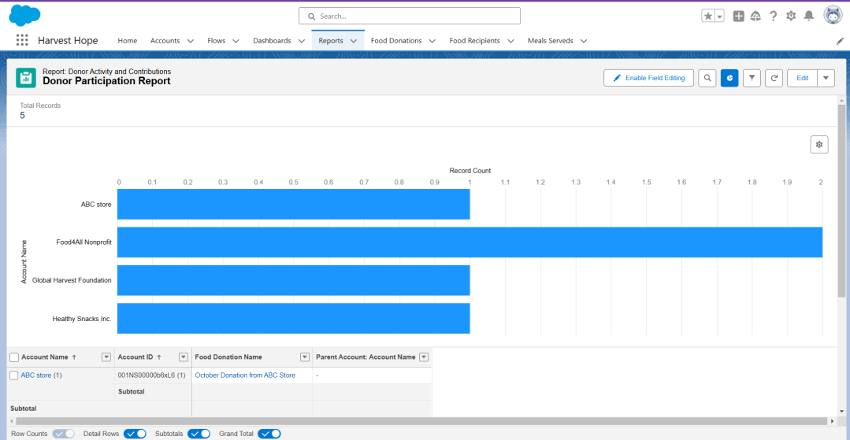

The image displays the "Donor Participation Report" in the "Harvest Hope" app on Salesforce. It features a bar chart showing donation record counts by donor name, with a data table below listing details for each donation entry.

* **Food Expiration Alerts**:

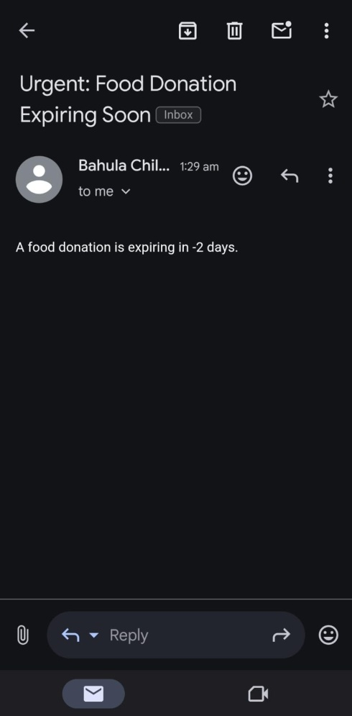:

The image shows an urgent email notification with the subject "Food Donation Expiring Soon" from developer. It alerts the recipient that a food donation is expiring in "-2 days," indicating a potential error in the expiration tracking.